UK fire stations existing lists

* <https://www.ukfirestations.co.uk/brigades> - also has a list of old firestations that are no longer in use

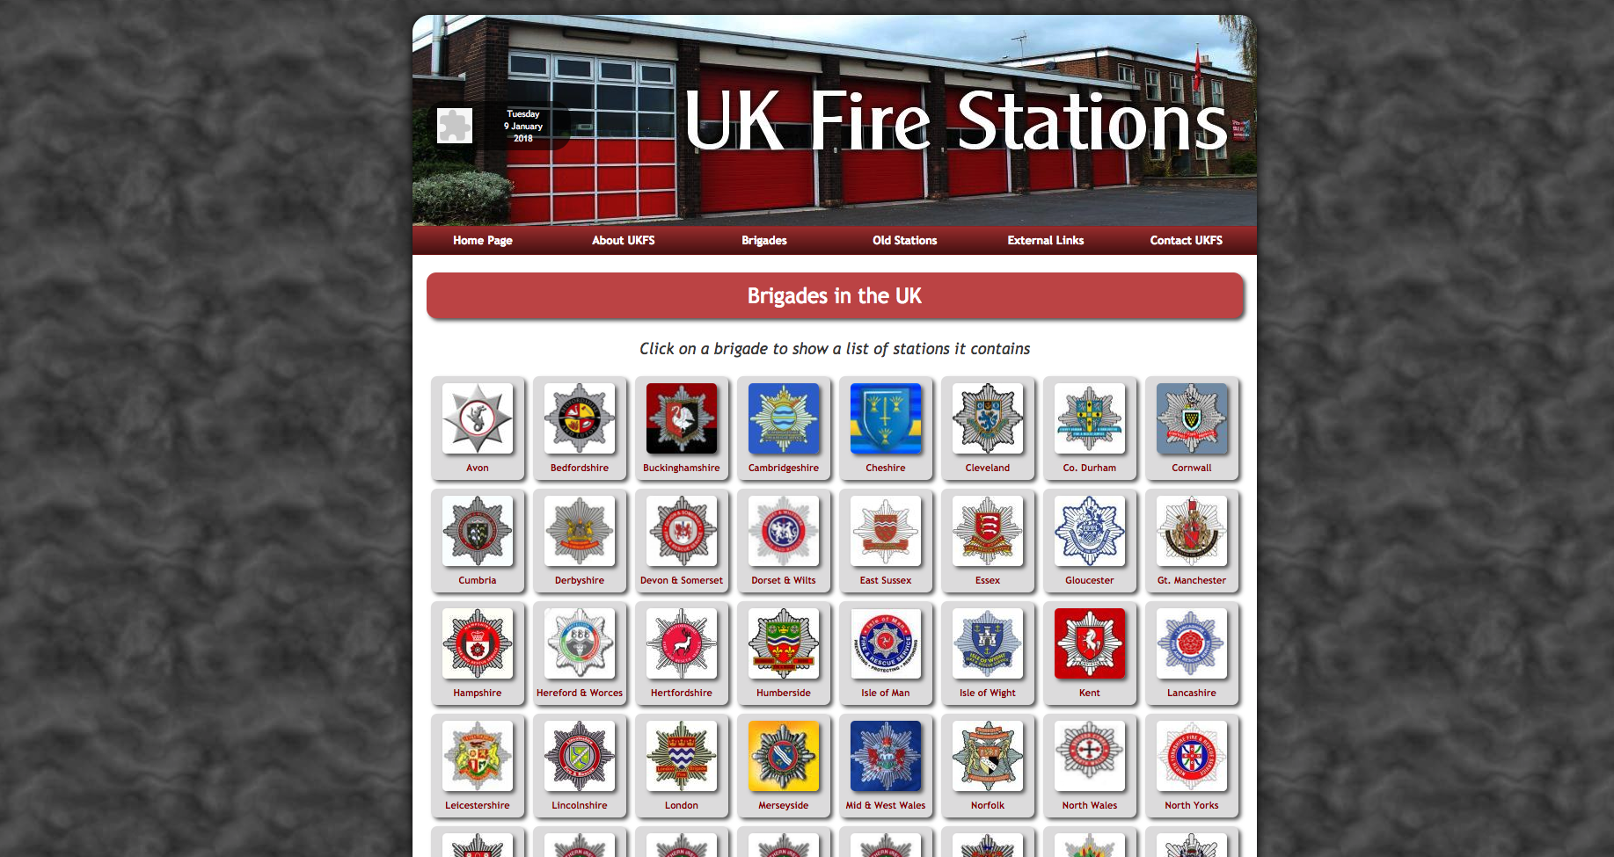

Each brigade is shown with their crest

Selecting a brigade will take you to a page detailing their stations both as a list and as a map

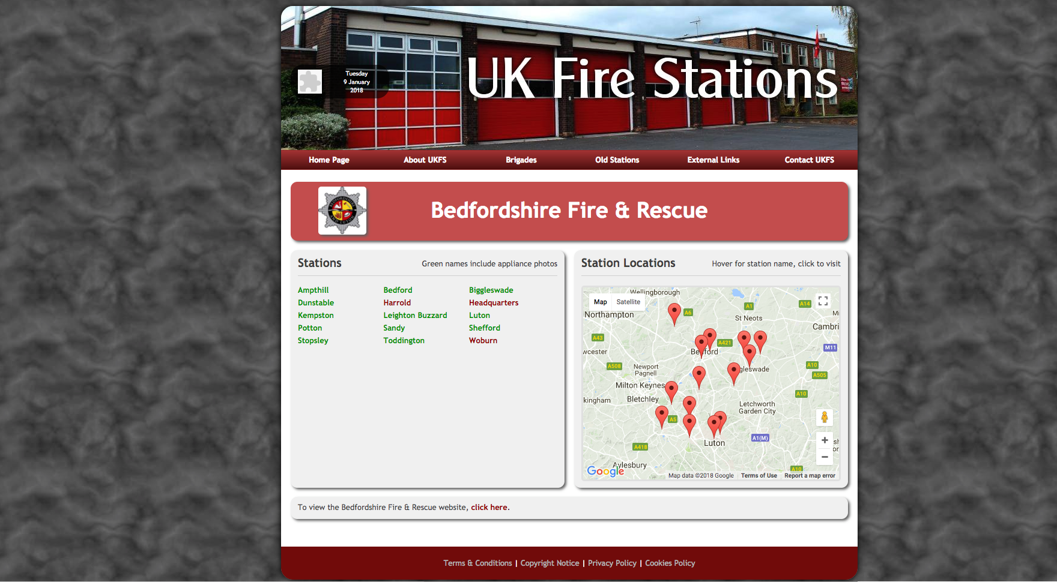

A station can then be selected to see further details about it including pics and a satalite image

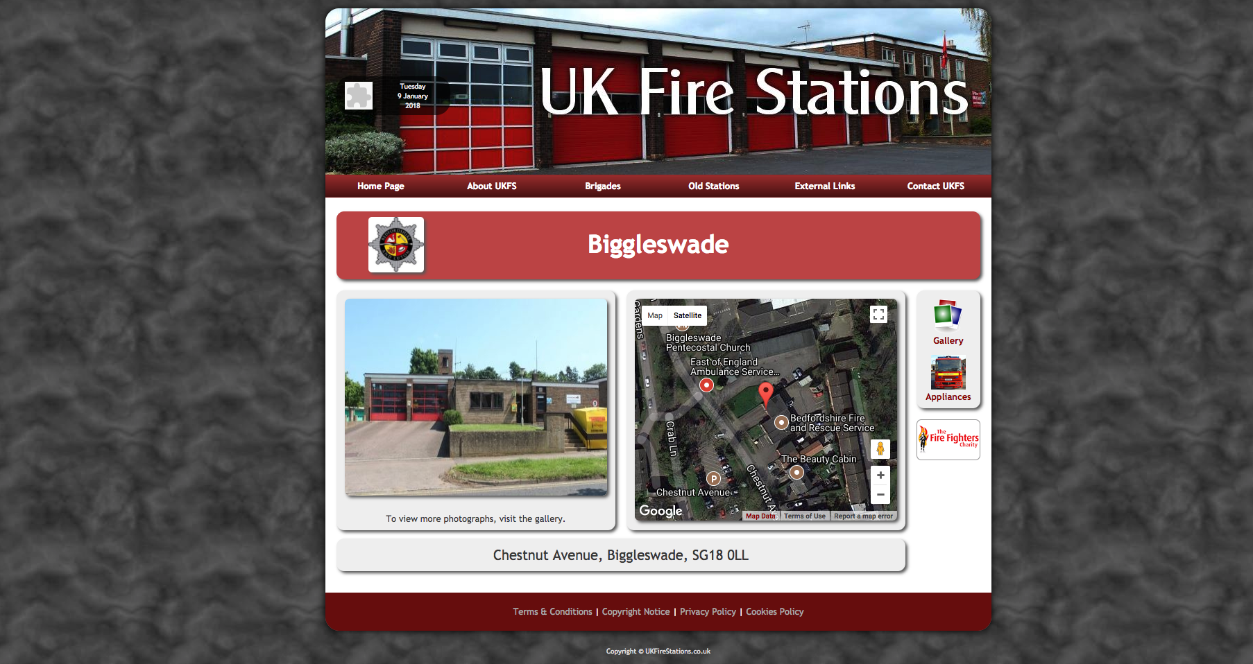

Here is their list: <https://docs.google.com/spreadsheets/d/1FzedwWuTs308_e6W00VP053KHlt3dKE2rp1ikiIlMO0/edit?usp=sharing>

List of the fire brigades with firestations, Could then look at each area one by one to pull the list

* <http://www.cfoa.org.uk/12072> - all the brigades but spread across many pages

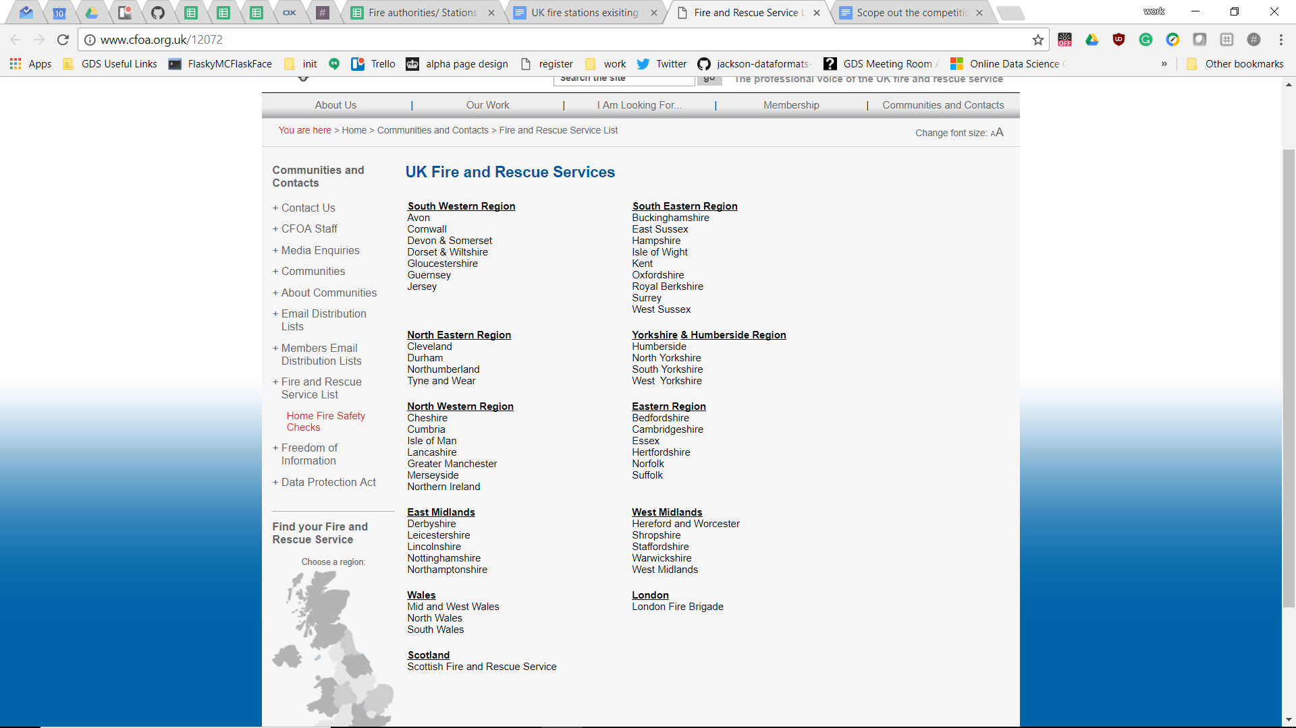

* <http://www.fire.org.uk/fire-brigades.html> - all the brigades on one page

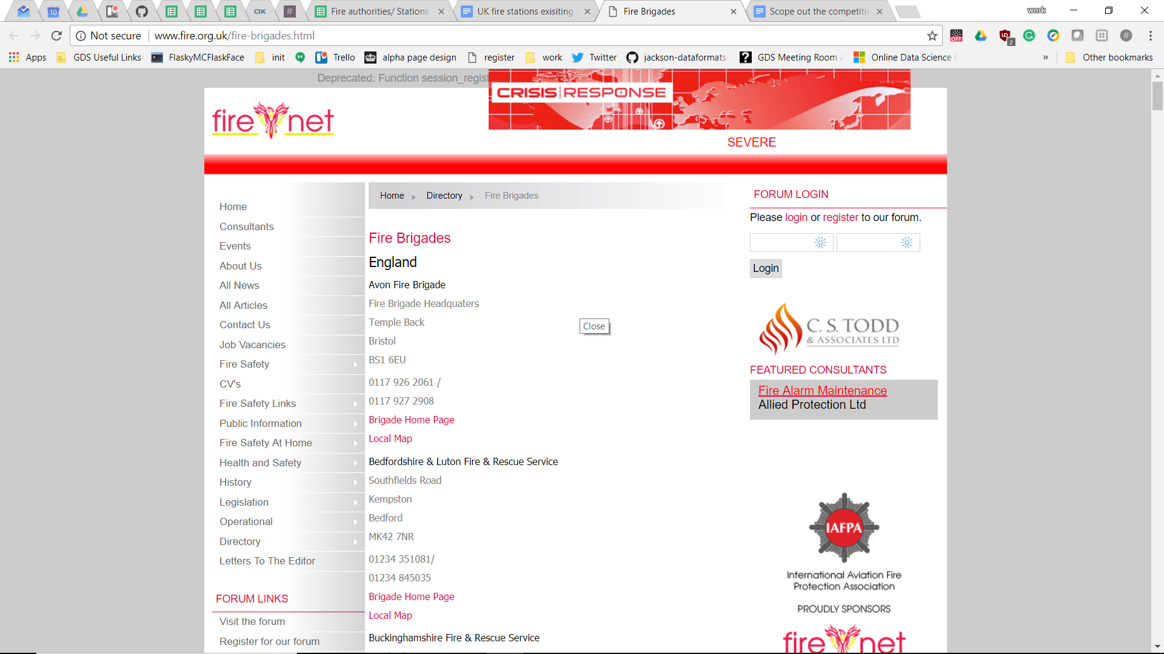

* Can extract the data and links from the html with a little cleaning.

Total number of fire stations (from 2012/13 so a little out of date now)

<https://www.gov.uk/government/uploads/system/uploads/attachment_data/file/262004/Appendix_1_to_13.xls>

Each service has their own website. (name of service)fire.gov.uk

These contain lists of the fire stations in various formats, the list could be collected form here but i see no way to automate the process. - often have links to an address sourced from google maps

* <https://en.wikipedia.org/wiki/Fire_services_in_the_United_Kingdom>
  + The wikipedia page has a list of of fire services. Each one of them has an independent page describing the station. I suspect there is some correspondence with dbpedia. In any case if would take time to gather all these information in a consistent way.
* Worth noting there is nothing useful in https://www.wikidata.org/wiki/Q3090847